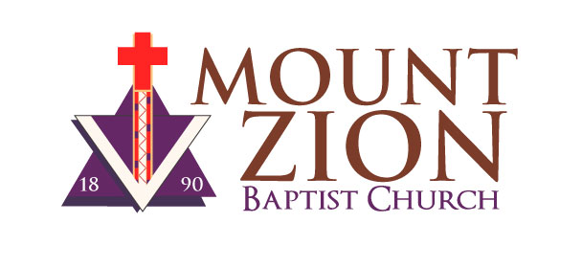
NOMINATION FORM
2025
Vacant Officer and Ministry/Board Positions

Complete and deliver to the Church Office c/o the Nominating Committee.
Deadline – October 10, 2024.

Nomination for (Position Name): __________________________________________

NOMINEE INFORMATION (Print or Type)

Name
Membership # | Year Joined
Street Address
City & ZIP
Home Phone*
Work Phone*
Cell Phone*
E-Mail
*Your address and at least one contact phone number are required.

QUALIFICATIONS
I acknowledge that I meet the qualifications below | YES | NO
- Must be an active MZBC member, at least 2 years, before making application for an elected position.
- Must be engaged in Bible Study.
- Must be a consistent giver for record to MZBC for two consecutive years prior to nomination.
- Must have demonstrated leadership skills & ability to organize a group to accomplish ministry goals.
- Must be a listener with the willingness to follow through with the work of the ministry.
- Must have the ability to follow through & complete the ministry’s work.
- Must be willing to attend a financial workshop if applicable for the position.
- Must submit to background check & bonding requirements, if they are applicable for the position.
Background Check Form required if nominating for Trustee Board, Christion Education, Treasurer/ Assist. Treasurer, Church School Superintendent/Assist. Superintendent, Finance Board or Building Ministry.

SIGNATURES:
Nominee:_______________________________________________ Date_________________

Signatures of two other Mount Zion Members in good standing (Required)

Nominated by: _______________________ Nominated by: _______________________
Print Name |  |  | Print Name
Phone No. |  |  | Phone No.
Date |  |  | Date
Please attach a biography (up to 150-word count) summarizing your church activities, plus your experience and expertise you will bring to the office or ministry position. You may attach your résumé if applicable to the role/position.

The Mount Zion Nominating Committee is seeking qualified members to fill officer and ministry positions for 2025. Those nominated shall be a member of Mount Zion, have the necessary skills for the position and be willing to carry out the responsibilities of the office. Interested members must be willing to submit to an interview to discuss their qualifications. Positions listed with an asterisk (*) require a background check.

The Committee also requests a typewritten biography of up to 150 words which includes a summary of the nominees’ church activities and the experience and expertise they will bring to the position. Nomination Forms will be available in the church lobby, church office, website (mountzion.net). Interested candidates may only run for one position per ballot. Submit it to the church office or email to Deacon Leslyn Jones-Petitt, Nominating Committee Chairperson at lespetitt@hotmail.com.

The following positions are open:

*Background check required

Open Church Officer Positions (1-Year Term):
Church Clerk | 1 position
Asst. Church Clerk | 2 positions
Asst. Treasurer | 1 position
At-Large Advisory Council (Adult) | 1 position
*Church School Superintendent | 1 position
*Asst. Church School Superintendent | 1 position
*Financial Secretary | 1 position
Church Representative to Church Council of Greater Seattle | 1 position

Open Ministry/Board Positions (3-Year Term):
*Building Ministry | 4-5 positions
*Christian Education Ministry Board  - Children  - Youth  - Young Adults  - Adults  - Leadership Development  - Mission Ed. | 6 positions
*Finance Board | 4 positions
Missions and Evangelism Ministry | 4-5 positions
*Trustee Board | 4 positions

Mount Zion Baptist Church is seeking members in good standing to be leaders of our Church. All members are welcome to participate in the annual elections of church offices. Elections will be held on Saturday, November 9, 2024, at 10:00 a.m. in the Fellowship Hall of Mount Zion Baptist Church. Nomination forms are available in the church lobby, church office and on our website, mountzion.net.

