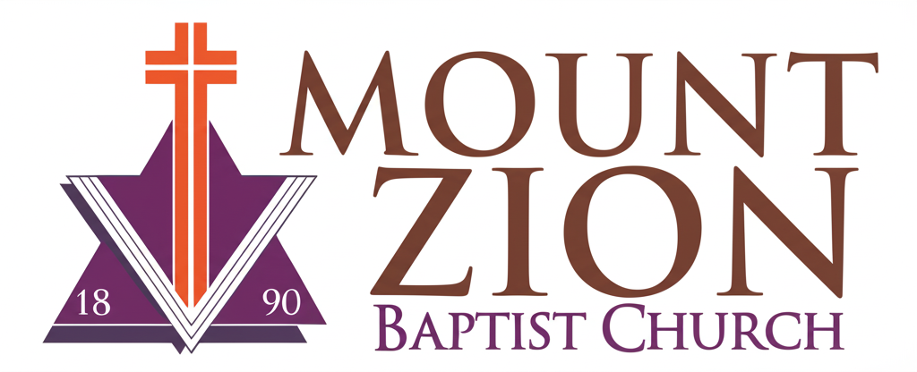
Mount Zion Baptist Church
1634 Rev. Dr. S. McKinney Avenue
Seattle, Washington 98122
206-322-6500
info@mountzionseattle.org
https://www.mountzion.net
https://mtzbcseattle.sharepoint.com
MOUNT ZION BAPTIST CHURCH
Donation/Pledge Form

Full Name: ___________________________
Phone/Email: __________________________
Donation Type: [ ] One-time [ ] Recurring
Amount: ______________________________
Method: [ ] Cash [ ] Check [ ] Online Giving [ ] In-Kind
Recognition Preference: ________________
Signature: __________________________ Date: ____________

