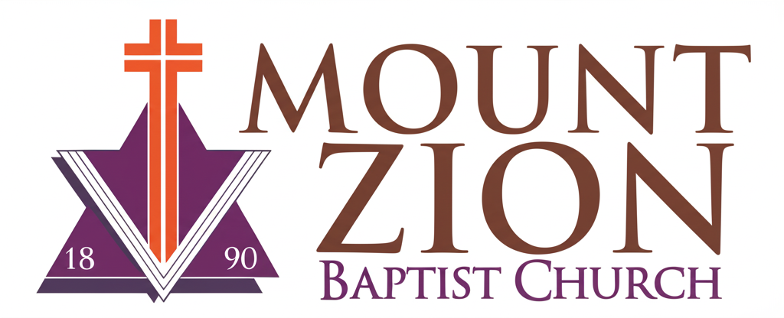
Mount Zion Baptist Church
1634 Rev. Dr. S. McKinney Avenue
Seattle, Washington 98122
206-322-6500
info@mountzionseattle.org
https://www.mountzion.net
https://mtzbcseattle.sharepoint.com
MOUNT ZION BAPTIST CHURCH
Volunteer Sign-Up Form

Full Name: ___________________________
Phone/Email: __________________________
Availability (Days/Times): _______________
Areas of Service (check all that apply):
[ ] Choir [ ] Usher [ ] AV/Tech
[ ] Children’s Ministry [ ] Outreach
Other: __________________________________
Signature: __________________________ Date: ____________

