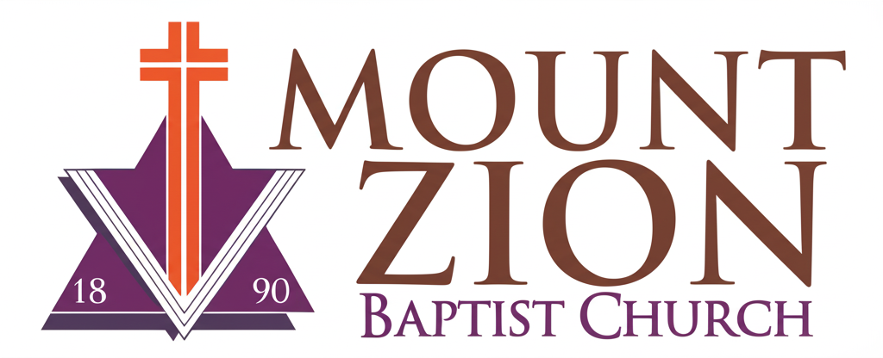
Mount Zion Baptist Church
1634 Rev. Dr. S. McKinney Avenue
Seattle, Washington 98122
206-322-6500
info@mountzionseattle.org
https://www.mountzion.net
https://mtzbcseattle.sharepoint.com
MOUNT ZION BAPTIST CHURCH
Baptism Request Form

Full Name: ___________________________
Date of Birth: ________________________
Phone: ______________________________
Email: ______________________________
Preferred Baptism Date: _______________
Spiritual Background: _____________________________________
Signature: __________________________ Date: ____________

