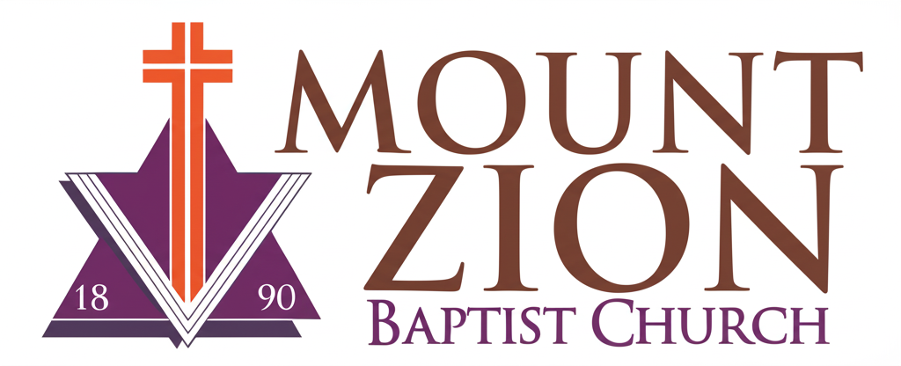
Mount Zion Baptist Church
1634 Rev. Dr. S. McKinney Avenue
Seattle, Washington 98122
206-322-6500
info@mountzionseattle.org
https://www.mountzion.net
https://mtzbcseattle.sharepoint.com
MOUNT ZION BAPTIST CHURCH
Facility Use Request Form

Event Name: __________________________
Organizer Name: _______________________
Phone/Email: __________________________
Event Date/Time: _______________________
Rooms/Equipment Requested: ____________
Expected Attendance: ___________________
Approval: _____________________________
Signature: __________________________ Date: ____________

