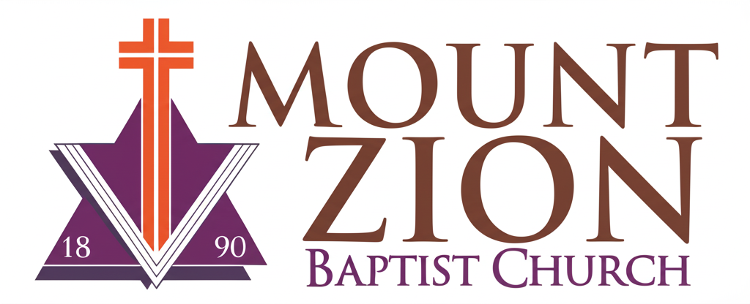
Mount Zion Baptist Church
1634 Rev. Dr. S. McKinney Avenue
Seattle, Washington 98122
206-322-6500
info@mountzionseattle.org
https://www.mountzion.net
https://mtzbcseattle.sharepoint.com
MOUNT ZION BAPTIST CHURCH
Funeral/Memorial Service Request Form

Deceased Name: _______________________
Date of Birth: _________ Date of Death: _________
Contact Person: _______________________
Phone/Email: __________________________
Requested Service Date/Time: ___________
Service Location: _______________________
Burial/Cremation Info: __________________
Special Notes: _________________________________________
Signature: __________________________ Date: ____________

