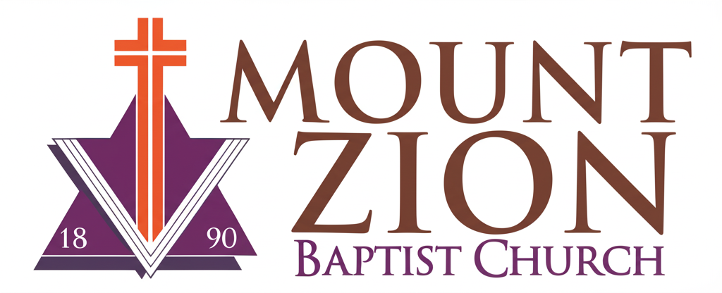
Mount Zion Baptist Church
1634 Rev. Dr. S. McKinney Avenue
Seattle, Washington 98122
206-322-6500
info@mountzionseattle.org
https://www.mountzion.net
https://mtzbcseattle.sharepoint.com
MOUNT ZION BAPTIST CHURCH
Membership Application Form

Full Name: ___________________________
Date of Birth: ________________________
Phone: ______________________________
Email: ______________________________
Address: ____________________________
Family Members: _____________________
Have you accepted Jesus Christ as your Savior? Yes [ ] No [ ]
Brief Testimony: __________________________________________
Areas of Ministry Interest: ________________________________
Signature: __________________________ Date: ____________

