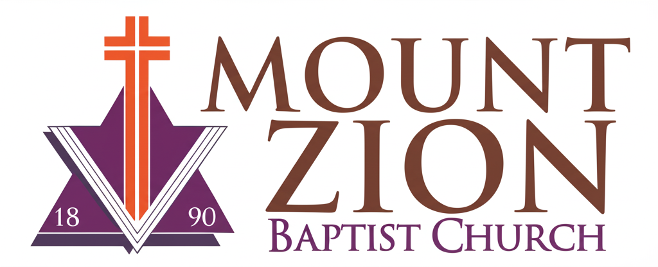
Mount Zion Baptist Church
1634 Rev. Dr. S. McKinney Avenue
Seattle, Washington 98122
206-322-6500
info@mountzionseattle.org
https://www.mountzion.net
https://mtzbcseattle.sharepoint.com
MOUNT ZION BAPTIST CHURCH
Wedding Request Form

Bride’s Name: _________________________
Groom’s Name: ________________________
Contact Phone/Email: __________________
Requested Ceremony Date/Time: __________
Pastor/Officiant Requested: _____________
Rehearsal Date/Time (if applicable): _______
Special Requests: _______________________________________
Signature: __________________________ Date: ____________

