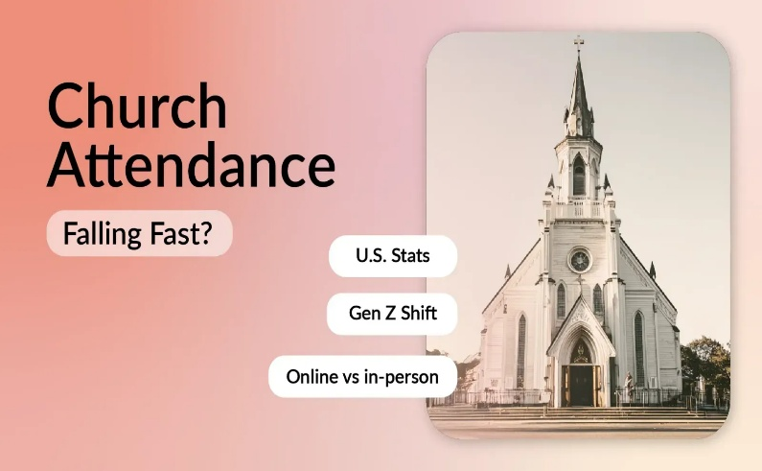
Church attendance in America isn't what it used to be.

If you're a church leader, you've probably felt it. Sunday morning looks different than it did five years ago, let alone fifteen. The reality?

- Only about 20% of U.S. adults attend church weekly today, down from roughly 30% two decades ago. Meanwhile, 57% now say they "seldom or never" attend religious services. [1]

But here's what matters most: understanding why people have stepped away is the first step toward welcoming them back. This isn't a doom-and-gloom post. It's a realistic look at church attendance trends backed by data from Gallup, Pew Research, and real conversations happening in online communities. What can churches do about it in 2026 with measurable actions and realistic expectations.

Key numbers to know:

- 1 in 5 Americans attends church weekly (church attendance rates at historic lows)
- 41% attend at least monthly, including those who go weekly
- 3 in 5 attend rarely or never
- ~85% of pre-pandemic attendance levels have returned in most churches
- 32% attended in-person in the past month (late 2024), while 27% watched online

Join It Website: https://joinit.com/blog/why-church-attendance-is-declining
Mt. Zion Retreat Handout
May 29-30, 2026
See website for more information

